

Student Name……………………………………

FURTHER MATHEMATICS

TRIAL EXAMINATION 2

2010

Reading Time: 15 minutes
Writing time: 1 hour 30 minutes

Instructions to students
This exam consists of Section A and Section B.
Section A contains a set of extended answer questions from the core, 'Data Analysis'.
Section A is compulsory and is worth 15 marks.
Section B begins on page 7 and consists of 6 modules. You should choose 3 of these modules and answer every question in each of your chosen modules. Each of the modules is worth 15 marks.
Section B is worth 45 marks.
There is a total of 60 marks available for this exam.
The marks allocated to each of the questions are indicated throughout.
Students may bring one bound reference into the exam.
An approved graphics or CAS calculator may be used in the exam.
Formula sheets can be found on pages 38 and 39 of this exam.
Unless otherwise stated the diagrams in this exam are not drawn to scale.

This paper has been prepared independently of the Victorian Curriculum and Assessment Authority to provide additional exam preparation for students. Although references have been reproduced with permission of the Victorian Curriculum and Assessment Authority, the publication is in no way connected with or endorsed by the Victorian Curriculum and Assessment Authority.

© THE HEFFERNAN GROUP 2010

This Trial Exam is licensed on a non transferable basis to the purchasing school. It may be copied by the school which has purchased it. This license does not permit distribution or copying of this Trial Exam by any other party.

SECTION A

Core

This section is compulsory.

The residents of a small rural town obtain their water from the town water supply or from their own water tanks or from a combination of both.

Question 1

The histogram below shows the distribution of the average daily town water consumption (in L) for 65 households that use only town water.

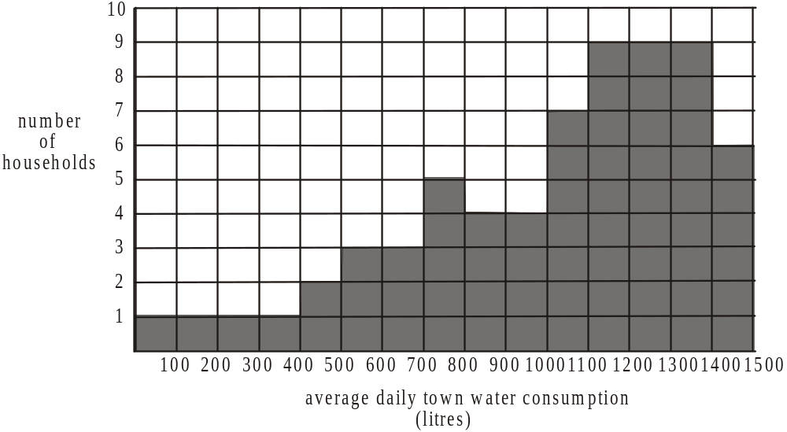

- Describe the shape of this histogram.

1 mark

- Write down the interval in which the median water consumption lies.

1 mark

- What percentage of these households use between 700L and 1000L of water per day?

1 mark
Question 2

Those households that use town water and tank water are classified as having small, medium or large tank capacity.
The box plots below show the distribution of the average daily town water consumption (in L) of these three groups of households.
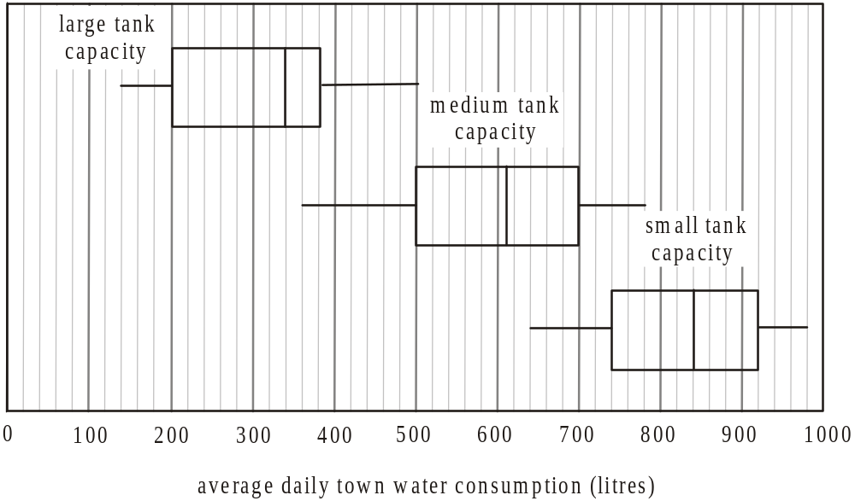

- What is the inter-quartile range of the distribution of town water consumption for those households with a medium tank capacity?

1 mark

- Complete the following statement.

The bottom 25% of households with large tank capacity have an average daily town

water consumption of between L and L per day.

1 mark

- For the three parallel box plots shown above, there appears to be an association between the variables tank capacity and town water consumption.
Using an appropriate statistic, describe the nature of this association.

1 mark

Question 3

The time series plot below shows the average daily town water consumption per household in the rural town each year for the decade 2000 – 2009.

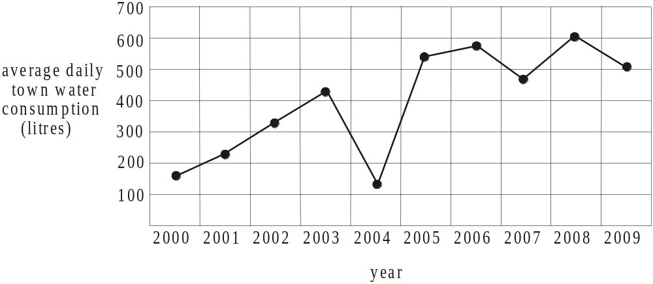

- On the plot above fit a 3-median trend line to the data. Draw an open circle around the three points that you use to find the 3-median line. It is not necessary to find the equation of this line.

2 marks

- By extrapolating the 3-median line found in part a., find what the average daily town water consumption (in L) is predicted to be in 2010.

1 mark

Question 4

The scatterplot below shows the monthly rainfall (in mm) and the monthly town water consumption (in kL) for each month in 2009 for a particular household. This household has large tank capacity.
A least squares regression line is fitted to the data.

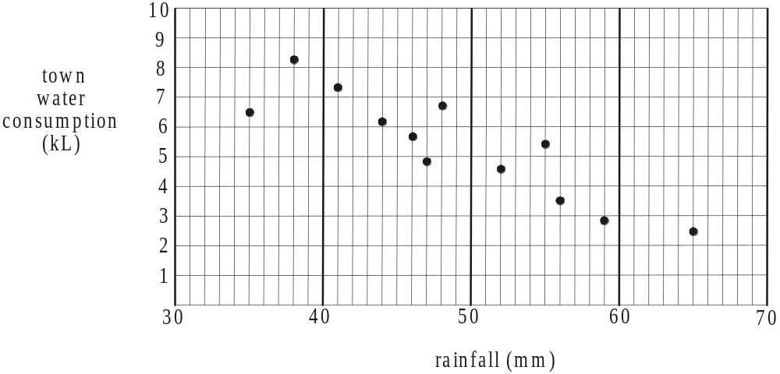

The equation of the least squares regression line for this set of data is

rainfall

The Pearson product moment correlation coefficient is 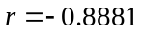.

- Complete the following statement.

On average for every 1mm increase in rainfall, there is a decrease of kL of town water consumption in this household.

1 mark

- What is the coefficient of determination for this set of data? Write your answer correct to four decimal places.

1 mark

- Explain what the coefficient of determination tells us in terms of the variables rainfall and town water consumption.

1 marks

Question 5

The tank capacity (in kL) and the town water consumption (in kL) for a particular month is recorded for twelve households. These results are shown in the table and the scatterplot below.
tank  capacity  (kL) | town water  consumption  (kL)
2 | 21
5 | 20
3 | 16
12 | 17
14 | 19
10 | 21
22 | 3
20 | 12
15 | 18
18 | 16
16 | 19
20 | 8

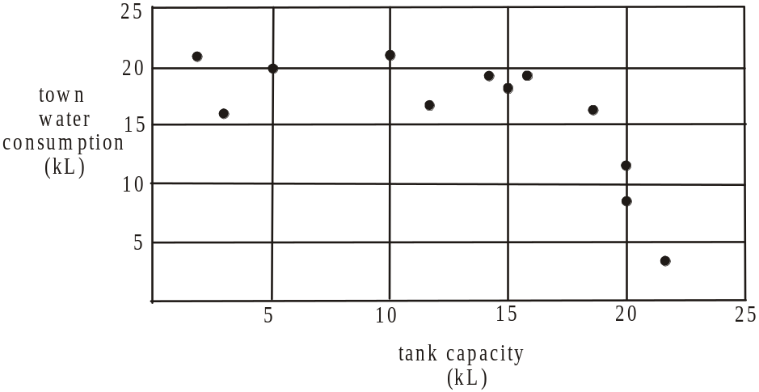

- Explain why it is decided not to find the equation of the least squares regression line for this set of data.

1 mark

A square transformation is to be applied to the variable tank capacity.

- Find the equation of the least squares regression line that enables town water consumption to be predicted by the square of tank capacity.
Express coefficients correct to 2 decimal places.

2 marks
Total 15 marks

SECTION B

Module 1: Number patterns

If you choose this module all questions must be answered.

Question 1

At a vineyard, the cabernet grape vines are planted with 7 vines in the first row, 11 in the second row, and 15 in the third row. The number of vines planted in successive rows form an arithmetic sequence.

- How many vines are planted in the twelfth row?

1 mark

- What is the total number of vines planted in the first thirty rows?

1 mark

- There are a total of 2772 cabernet grape vines planted and there are 147 vines planted in the last row.
How many rows of cabernet grape vines are there?

1 mark

Question 2

At this vineyard the harvest of shiraz grapes in successive years forms a geometric sequence with a common ratio of 1.04. The harvest of shiraz grapes in the first year is 50 tonnes.

- What is the harvest; in tonnes, of shiraz grapes in the third year? Express your answer correct to 1 decimal place.

1 mark

- What is the percentage increase in the shiraz grape harvest each year?

1 mark

- In which year will the harvest of shiraz grapes first exceed 100 tonnes?

1 mark

- What is the total harvest of shiraz grapes in the first 30 years of production? Express your answer in tonnes correct to 1 decimal place.

1 mark

At the end of 30 years, if no new plantings are made, the harvest of shiraz grapes at this vineyard is forecast to decline at the rate of 8% per year.
The difference equation below models this period of decline, with 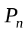 representing the production of Shiraz grapes in the n^{th} year of this period of decline.

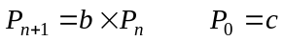

- Write down the value of b and c. Express c correct to 1 decimal place.

2 marks

- What would the total harvest of shiraz grapes be; in tones; correct to 1 decimal place, over this period of decline?

1 mark

Question 3

A disease kills 10% of the chardonnay vines during each year of production at the vineyard. Each year a certain number of chardonnay vines are replanted. This number has remained unchanged from year to year.
The difference equation below models the number of chardonnay vines at the vineyard in n^{th} year of production.

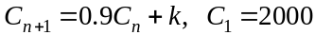

- If the number of chardonnay vines at the vineyard is to remain at 2000, find the value of k.

1 mark

Suppose that the number of chardonnay vines replanted each year had been 100.

- Find the number of chardonnay vines that there would have been at the vineyard in the third year of production.

1 mark

- Show that the sequence of terms generated by the difference equation given above when is not geometric.

1 mark

For the production of chardonnay wine at the vineyard to remain viable, the number of chardonnay vines must not fall below 800 over the long term.

- Explain whether or not the replanting of 100 chardonnay vines each year would be enough to ensure the long term viability of chardonnay wine at the vineyard.
Show appropriate working to justify your decision.

2 marks
Total 15 marks

Module 2: Geometry and trigonometry

If you choose this module all questions must be answered.

Question 1

A rain gauge in the shape of a right triangular prism, with height 30cm and width 8cm is shown below.
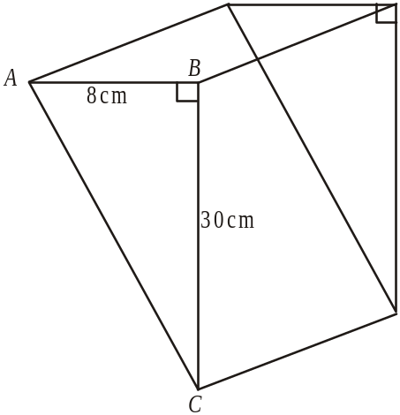

- Calculate the distance AC, in cm, correct to two decimal places.

1 mark

- Calculate the angle ACB.
Write your answer in degrees correct to two decimal places.

1 mark
c. One day after it had rained, the height of the rain water in the gauge was 10cm.
What fraction of the gauge’s volume did the rain water occupy?

2 marks
Question 2

Weather recording equipment is kept in a structure with a base in the shape of a cube with side lengths of 40cm. A cover in the shape of a right square pyramid with slant sides of 35cm and base sides of 40cm sits on the base as shown in the diagram below.

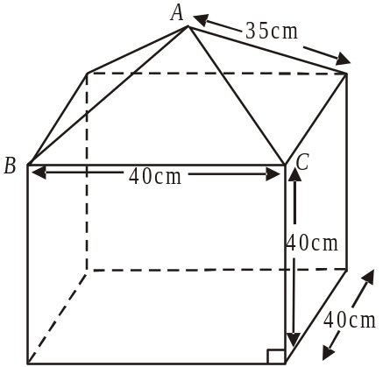

- Use Heron’s formula to calculate the area of the triangular face ABC of the pyramid. Express your answer in cm² correct to two decimal places.

2 marks

- Find the surface area of the structure including the underside of the base. Express your answer to the nearest cm².

1 mark
- Show that the height of the pyramid is 20.6cm correct to 1 decimal place.

2 marks

- Using the result from part c., calculate the volume of the complete structure. Express your answer to the nearest cm³.

1 mark

Question 3

The rain gauge is fixed in a position at R on flat ground in the open. A tree, T, is 20m away on a bearing of 160° from the rain gauge. A shed, S, is 45m away on a bearing of 230° from the rain gauge as indicated in the diagram below.

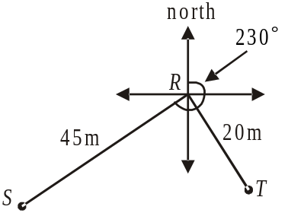

- How far due south of the rain gauge is the tree? Express your answer in metres correct to 1 decimal place.

1 mark

- Find angle SRT.

1 mark

- Calculate the distance ST, in metres, correct to one decimal place.

1 mark

- What is the bearing of the tree from the shed to the nearest degree?

2 marks
Total 15 marks
Module 3: Graphs and relations

If you choose this module all questions must be answered.

Question 1

Mick works for a company that hires out equipment and furniture for corporate events. He is paid for the time that he works and his pay rate is determined by the task he is undertaking.

On one particular day between 7am and 2pm, Mick’s tasks, in order, include driving, then unloading and then setting up with a break in between each task.

The graph below shows Mick’s pay-time graph for this particular day.

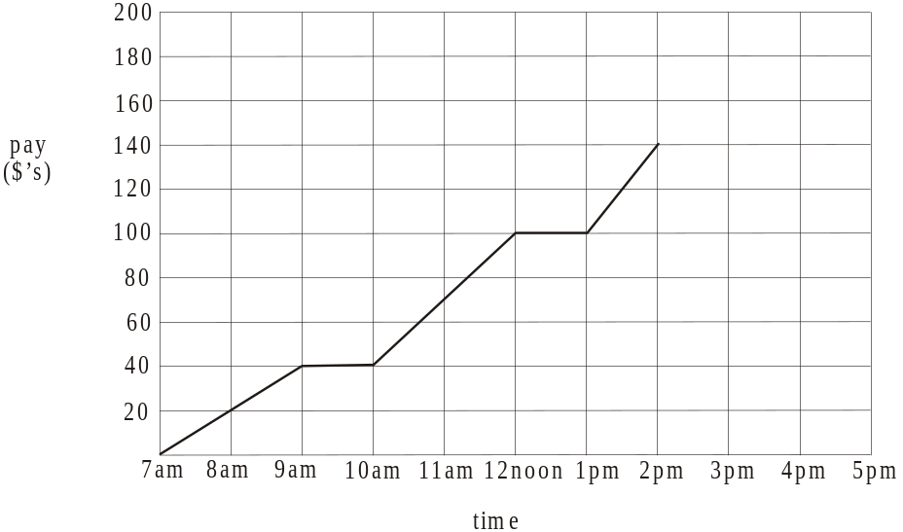

- How much pay had Mick earned by 9am?

1 mark

- For how many hours between 7am and 2pm was Mick not being paid?

1 mark

- What is Mick’s pay per hour for driving?

1 mark

- Between 2pm and 4pm Mick’s task is cleaning up for which he is paid $20 per hour.
On the graph above, draw in the line segment that represents this.

1 mark
- Which of the four tasks of driving, unloading, setting up and cleaning up earns Mick the highest hourly rate of pay?
Justify your answer.

1 mark

Question 2

The hiring company imposes fines for the late return of equipment.
The table below shows the fine, F in dollars, for the return of a sound system t days late.
Also shown are some values for t³ (days³).

t (days) | 0 | 2 | 3 | 5
t³ (days³) | 0 | 8 | 27
F (dollars) | 0 | 96 | 324 | 1500

The graph below shows three points that have been plotted which represent the relationship between F and t³.

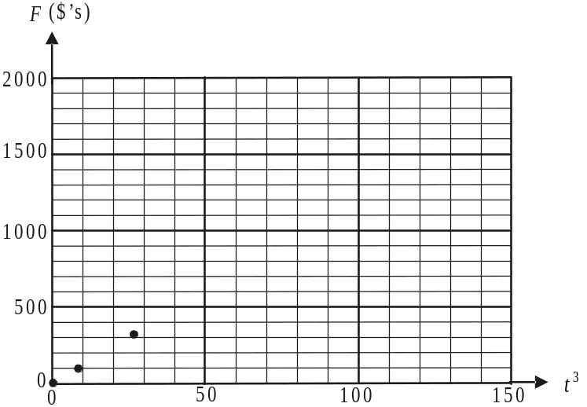

- Complete the table above by filling in the shaded cell and plot the point on the graph above.

1 mark

- The relationship between F and t³ is given by the equation 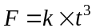.
Find the value of k.

1 mark

- What is the fine imposed for a sound system that is returned 7 days late?

1 mark

- A client had to pay a fine which he remembered being more than $750. What was the minimum number of days late that he might have returned a sound system?

1 mark

Question 3

The hiring company has a fleet of small and large trucks which are used to deliver equipment and furniture.
Each small truck requires two people on board and each large truck requires three people.
On a particular day, there are only 10 people who can go out on the trucks.
Also on this particular day, there are only 4 small trucks and 3 large trucks that are available for deliveries.

Let x be the number of small trucks out delivering in a day.
Let y be the number of large trucks out delivering in a day.

The constraints on the number of trucks out delivering are given by
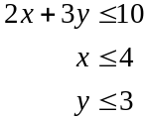
and 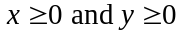.
The lines 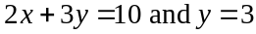 are graphed below.

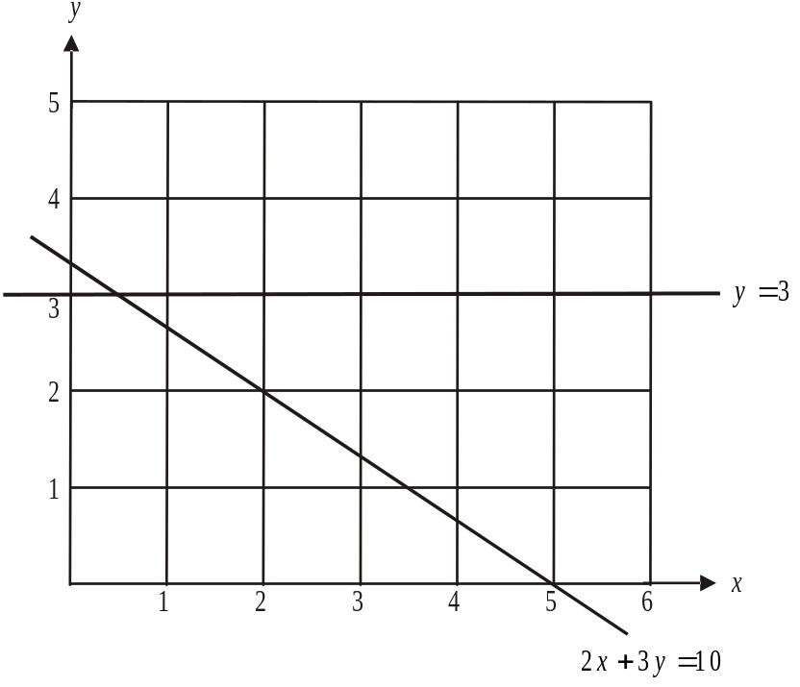

- On the graph above, sketch the line .

1 mark

- Show the feasible region on your graph and find how many points on the graph satisfy the constraints of small and large trucks that could be out delivering on this particular day.

1 mark
For each small truck that is out delivering, the company can make a profit of $3 400 in a day. For each large truck the profit can be $5 200.

- Find the maximum profit that can be made on this particular day.

2 marks
A further limitation on the use of the trucks occurs because of a fuel shortage.

On average, a small truck uses 125 litres of fuel per day and a large truck uses 250 litres.
The company has access to 500 litres of fuel a day.

- How many small and large trucks should be out delivering in a day to maximize profit during this fuel shortage?
(The graph given earlier showing the lines is shown again below to assist with your solution.)
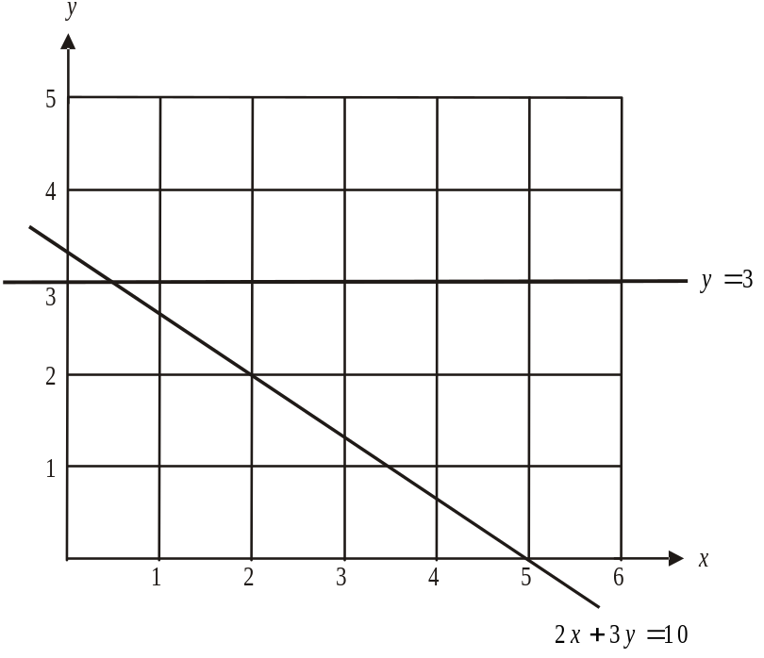

2 marks
Total 15 marks
Module 4: Business-related mathematics

If you choose this module all questions must be answered.

Question 1

The retail price of a dishwasher in a store is $1 400.

- If the dishwasher is paid for in cash, a discount of 5% of the retail price is given.
How much is this discount?

1 mark

- If the dishwasher is purchased in the last week of June a discount of $350 is given.
What percentage discount of the retail price does this represent?

1 mark

- If a certain credit card is used to pay for the dishwasher, a charge of 0.5% of the retail price of the dishwasher is added to the retail price.
How much would you pay for the dishwasher if you were using this type of credit card?

1 mark

Question 2

Remo purchases one of these dishwashers with a retail price of $1 400 for his business premises.
He enters a credit arrangement with the store. He pays a deposit of $200 and makes 24 monthly payments of $55.

- What is the total amount of interest he pays for the dishwasher?

1 mark

- What annual flat rate of interest does this represent?

1 mark

Question 3

Remo purchases $15 000 worth of office equipment for his business, which he depreciates for tax purposes.

- Using flat rate depreciation of 6% per annum, find the value of the office equipment after

- 1 year

- 5 years

- Using reducing balance depreciation of 6% per annum, find the amount that the office equipment depreciates during the fourth year after purchase.

2 marks

Question 4

Remo borrows $15 000 to purchase the office equipment. When the arrival of the equipment is delayed, he invests the $15 000 in an account that earns interest of 10.4% per annum compounding weekly.

- What amount will be in this account at the end of 12 weeks?

2 marks

- After how many weeks does the amount of interest earned first exceed $500?

1 mark

Question 5

Remo borrowed the $15 000 using a reducing balance loan. The interest on the loan is calculated monthly, the monthly repayments are $298.44 and the loan will be paid out after 5 years.

- What is the annual interest rate on this loan? Express your answer as a percentage correct to 1 decimal place.

1 mark

- If interest rates were increased to 7.5% per annum two years into the loan, and the loan were still to be paid out in 5 years, by how much would Remo’s monthly payments increase?

2 marks
Total 15 marks

Module 5: Networks and decision mathematics

If you choose this module all questions must be answered.

Question 1

A group of five friends, Tom, Leigh, Pete, Sanjo and Jack set up a landscape gardening business. Each of the five has an expertise in at least one of the five main areas of the business. Each of the men is to be put in charge of one of the areas that they have expertise in so that all areas have someone in charge.
The bipartite graph below shows the names of the five men and the areas in which they have expertise.

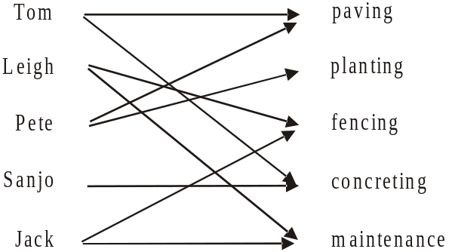

- Which area must Tom be put in charge of?

1 mark

- How many areas have only one person who can feasibly be put in charge?

1 mark

Question 2

The landscape gardening business has 7 jobs currently running. The network below shows the roads that are used to travel between the jobs which are labelled A – G.

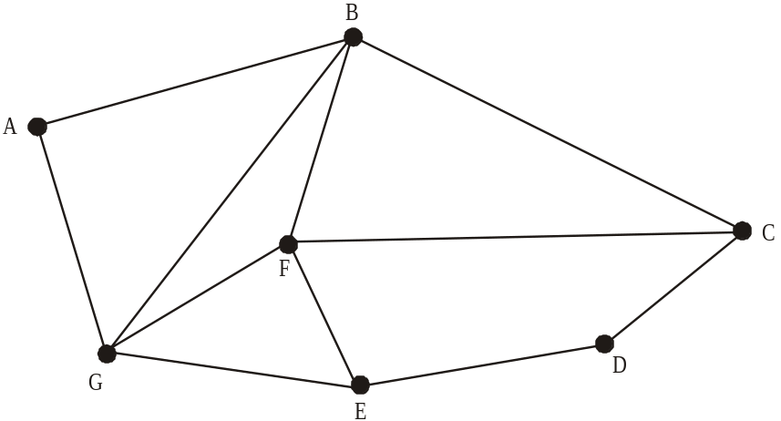

- Find the sum of the degrees of the vertices of the network shown above.

1 mark

- Write down a route that starts at A and represents a Hamiltonian path.

1 mark

Whilst travelling between jobs, Leigh loses something from the back of his ute. He plans a route so that he travels just once on each of the roads shown on the network in order to look for the missing item.

- Which vertex or vertices could he start from to achieve this?

1 mark

Question 3

The five men are keen golfers and play each other regularly.
The directed graph below shows the most recent results when the men have played in pairs.

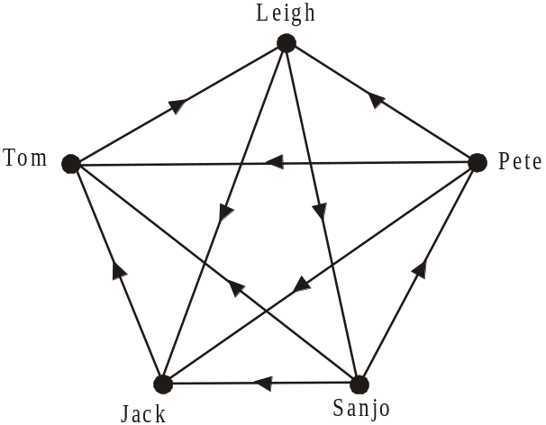

Key
Tom Leigh
indicates Tom defeated Leigh

The dominance matrix, showing one-step dominance for the men in their recent golf results is shown below.
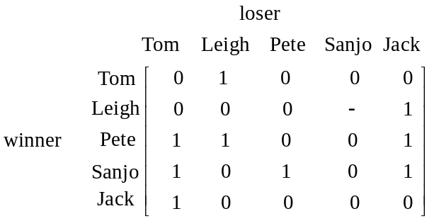

- Write down the missing entry in the matrix above.

1 mark

- Which two men have equal highest totals of one-step dominance?

1 mark

- By adding together the total of one-step and two-step dominances, find the most dominant golfer and the least dominant golfer amongst the five men.

most dominant golfer

least dominant golfer
2 marks
Question 4

Jack has identified ten activities that must be performed in order to complete a job that the business has running.
Those activities together with the time that they take to complete in days are shown on the directed network below.

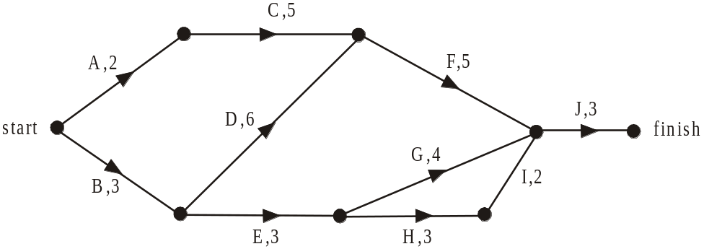

- What is the earliest start time for activity F?

1 mark

- What is the latest start time for activity H?

1 mark

- What is the minimum time that the job can be completed in?

1 mark

Just prior to the job beginning, the property owner changes the design so that activity D is removed from the job.
The new directed network reflecting this change is shown below.
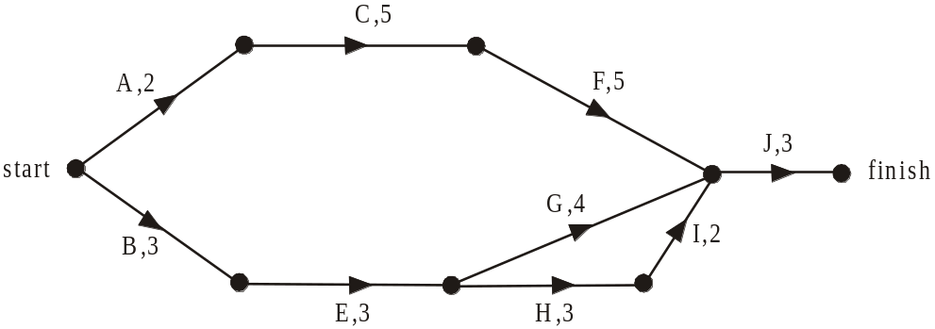

- By how many days does this reduce the completion time?

1 mark

The property owner also wants the job to be completed in 10 days.
Jack determines that only activities F, G, H and J can be reduced and that the minimum time each can be reduced to is 1 day. The cost to the owner is $1000 per day for each activity that is reduced.

- Complete the table below showing the number of days each of these four activities should be reduced so that the job is reduced to 10 days at the least cost.

Activity | Number of days to be reduced
F
G
H
J

2 marks
Total 15 marks
Module 6: Matrices

If you choose this module all questions must be answered.

Question 1

A catering business uses olive oil and vegetable oil in its kitchens.
The cost per litre of olive oil and of vegetable oil from three different wholesalers
X, Y and Z is shown in matrix C below.

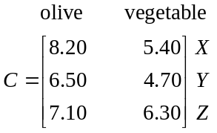

- Write down the order of matrix C.

1 mark

The number of litres of olive oil and vegetable oil used by the business last month is given by the matrix M.
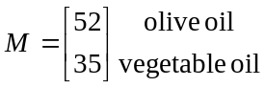

- Evaluate the matrix CM.

1 mark

- What would have been the cost of purchasing the oil used last month from wholesaler Y?

1 mark
Question 2

The catering business specializes in monthly boardroom lunches and offers its regular corporate clients three options – the seafood lunch, the sandwich lunch and the Italian lunch.

Over time it is found amongst its regular corporate clients ordering these boardroom lunches that
- 72% ordering the seafood lunch this month order the seafood lunch next month
- 15% ordering the seafood lunch this month order the sandwich lunch next month
- 13% ordering the seafood lunch this month order the Italian lunch next month

- 81% ordering the sandwich lunch this month order the sandwich lunch next month
- 11% ordering the sandwich lunch this month order the seafood lunch next month
- 8% ordering the sandwich lunch this month order the Italian lunch next month

- 68% ordering the Italian lunch this month order the Italian lunch next month
- 21% ordering the Italian lunch this month order the seafood lunch next month
- 11% ordering the Italian lunch this month order the sandwich lunch next month

- Use this information to complete the transition matrix below.

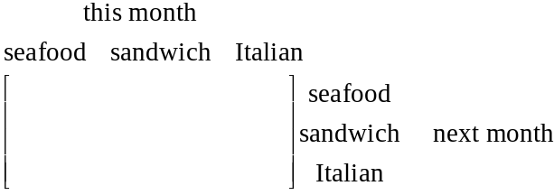
1 mark

- Last month, 23 seafood, 29 sandwich and 16 Italian boardroom lunches were ordered by the regular corporate clients.

- Express this information as a column matrix.

- Hence find the number of seafood boardroom lunches expected to be ordered by the regular corporate clients this month.

Question 3

One night the catering business has a 50th birthday, a 21st birthday and a wedding to cater for.
The total number of hours worked by bar staff, waiting staff and kitchen staff is given by the matrix F.

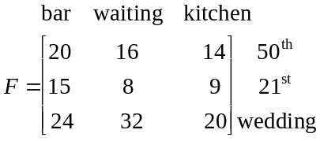

- Find the inverse matrix, 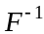, of matrix F.

1 mark

The hourly pay rate paid to bar staff, waiting staff and kitchen staff is $x, $y and $z respectively.
The matrix equation below gives the total amount paid to the staff at the three functions on this night.

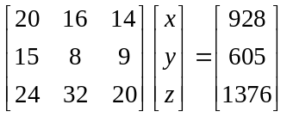

- What was the total amount paid to the staff working at the 21st?

1 mark

- Use the matrix equation above to find the hourly rate paid to kitchen staff.

1 mark
Question 4

The accounts manager of the catering business notices over time a change in the number of regular clients who pay their accounts electronically rather than by other methods such as cheque or cash.
The transition matrix, T, below, shows this.

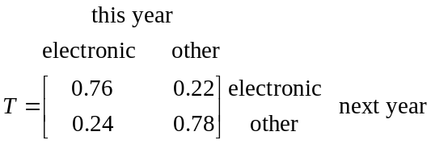

In the first year that the catering business offered electronic payment to its regular clients, 21 paid electronically and 164 paid by other means.
The payment matrix shows this.
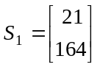
- How many regular clients did the catering business have in its first year of offering electronic payment?

1 mark

- Assuming that the number of regular clients remains the same, how many regular clients

  - pay electronically in the second year that this method of payment was available?

  - pay electronically in the long term?

- The catering business has a change of ownership.
The number of regular clients who pay electronically or by other means during the n^{th} year of this new ownership is given by the matrix 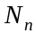 where

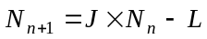

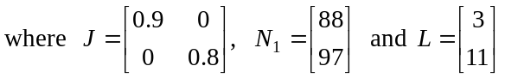.

In the first year of this new ownership, 88 regular clients paid electronically and 97 paid by other means.

- How many regular clients paid electronically during the second year of the new ownership?

- How many regular clients were lost between the first and third year of the new ownership?

Total 15 marks

Further Mathematics Formulas

Core: Data analysis
standardised score: 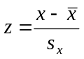
least squares line: 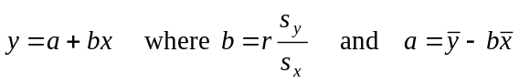
residual value: residual value = actual value – predicted value

seasonal index: seasonal index 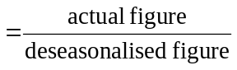

Module 1: Number patterns
arithmetic series: 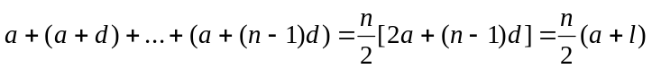
geometric series: 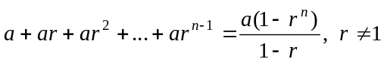
infinite geometric series: 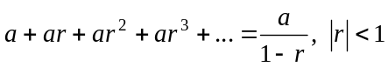

Module 2: Geometry and trigonometry
area of a triangle: 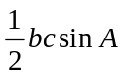
Heron's formula: 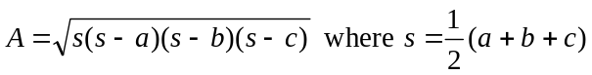
circumference of a circle: 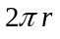
area of a circle: 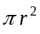
volume of a sphere: 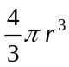
surface area of a sphere: 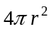
volume of a cone: 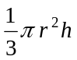
volume of a cylinder: 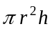
volume of a prism: 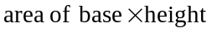
volume of a pyramid: 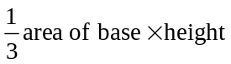

Reproduced with permission of the Victorian Curriculum and Assessment Authority, Victoria, Australia.
These formula sheets have been copied in 2010 from the VCAA website www.vcaa.vic.edu.au
The VCAA publish an exam issue supplement to the VCAA bulletin.
Pythagoras’ theorem 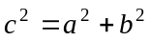
sine rule: 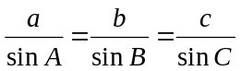
cosine rule: 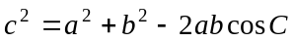

Module 3: Graphs and relations

Straight line graphs

gradient (slope): 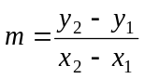
equation: 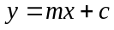

Module 4: Business-related mathematics

simple interest: 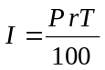
compound interest: 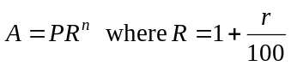
hire purchase: 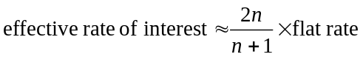

Module 5: Networks and decision mathematics

Euler’s formula: 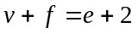

Module 6: Matrices

determinant of a 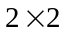 matrix 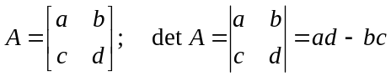
inverse of a matrix 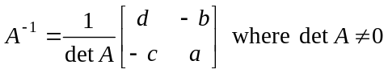

END OF FORMULA SHEET

Reproduced with permission of the Victorian Curriculum and Assessment Authority, Victoria, Australia.
These formula sheets have been copied in 2010 from the VCAA website www.vcaa.vic.edu.au
The VCAA publish an exam issue supplement to the VCAA bulletin.

